Utility Company Notification

LVAD therapy is considered life sustaining equipment dependent upon electricity. Do not risk your power being shut off!! You must pay your bill in order to prevent a power shut off. If you are having a financial hardship, call the utility company and inquire about budget plans for payment.

- Please call your power company in order to have your account registered as having a household member dependent on electricity.
- Provide VAD coordinator company name, account # and payee and we will provide you with a physician signed letter noting dependence on electricity. Please make copies of this letter and give to your utility company as needed.
- If the power company mails you an application to complete, please be sure to bring this into our VAD clinic as this application often will require MD signature.
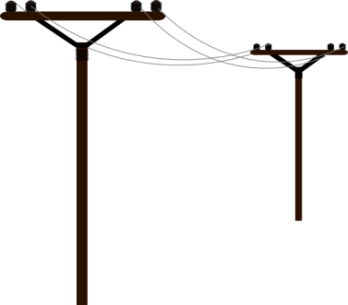
- Please bring to clinic any power company letter confirming you are on their list so that we may have a copy.

NYS Utility Companies

- National Grid:
  - 1-800-642-4272
  - https://www.nationalgridus.com/Upstate-NY-Home/Storms-Outages/Life-Sustaining-Equipment
- Rochester Gas and Electric (RG&E)
  - 1-800-743-1701
  - https://www.rge.com/UsageAndSafety/electricalsafety/stormsafety.html
- New York State Electric and Gas (NYSEG)
  - 1-800-572-1111
  - https://www.nyseg.com/YourAccount/payyourbill/serviceandassistance/default.html?menu=1188

Be Prepared for a Power Outage

- Visit your utility company website for information on home safety.
- Keep spare batteries charged.
  - A HeartMate II patient who loses power should have at least 36 hours of power if all 8 batteries are fully charged.
  - A HeartMate 3 patient who loses power should have at least 60 hours of power if all 8 batteries are fully charged.
- Keep cell phone charged.
- Purchase of a generator is not required for LVAD therapy, however many people purchase if you live in an area prone to frequent power outages.
- Set up a call tree of friends, family and neighbors you can stay with until your power is turned back on.
- Bring your medicines, dressing supplies, battery charger, mpu, backup controller.
- Call the VAD clinic if you expect your power to be out more than 12 hrs.
- Call 911 for power emergencies. Local fire departments and hospitals can provide power.
